Quantum Enhanced Machine Learning Model for the Diagnosis of Alzheimer’s Disease

Nancy Noella R S¹, Bhuvanesh Unhelkar², Siva Shankar Subramanian³, G Nagarajan⁴
¹Post Doctoral Researcher, Information Systems and Decision Sciences, University of South Florida (USF),8350N. Tamiami Trail Sarasota, Florida, USA.
¹Department of CSE, Sathyabama Institute of Science and Technology, Chennai, India,600119
²Professor, Information Systems and Decision Sciences, University of South Florida,8350N. Tamiami Trail Sarasota, Florida, USA.
³Departmentof CSE, KG Reddy College of Engineering and Technology, Moinabad, Telangana, India–501504
⁴Department of CSE, Sathyabama Institute of Science and Technology, Chennai, India, 600119
Email ID: ¹nancynoella.cse@sathyabama.ac.in; ²bunhelkar@usf.edu; ³drsivashankars@gmail.com; ⁴gnagarajan.cse@sathyabama.ac.in

Abstract: Alzheimer’s is a progressive and degenerative brain disorder causing impairment in memory and cognitive function. It is the most common form of Dementia and the prevalence of Alzheimer’s disease (AD) increases with each decade of life. This usually starts in late middle age to old age resulting in progressive memory loss, impaired thinking, disorientation and changes in personality. Neurons are first lost in the hippocampus (the brain’s centre for memory and learning), and presence of neurofibrillary tangles and plaques containing beta-amyloid cells. Owing to the progressive nature of the disease and the complex structure of the brain, the exact causes, mechanisms and how Alzheimer’s spread is not completely understood thereby inhibiting in the production of a cure for the disease. Quantum Machine Learning (QML) is a promising area of research for the detection and diagnosis of Alzheimer’s disease. PET scan helps in diagnosing Alzheimer’s by detecting the amyloid plaques and tau tangles. It reveals areas with reduced metabolism, which helps differentiate Alzheimer’s from other conditions. Quantum computing provides a more efficient model for different disease classification tasks than classical machine learning approaches. In this study, we propose a model based on quantum machine learning classifiers to classify Alzheimer’s disease. This showcases the feasibility of Quantum enhanced classification and detection of AD for extremely limited medical datasets.
Keywords: Alzheimer’s disease, Pet Imaging, Convolutional Neural Network, Quantum Machine Learning, Quantum Support Vector Machine, hybrid Quantum classical model.

Introduction
Alzheimer’s is a neurodegenerative disorder where the symptoms gradually worsen and more nerve cells get lost over time. There is cellular damage which results due to the neurons losing function and eventually die.
Currently these diseases are incurable; however, some symptoms can be manageable with treatments. This is largely due to the complex structure of the brain and multiple combinations of symptoms. The disease is characterized by the accumulation of the amyloid plaques and misfolding of the tau proteins. However, the mechanism of the disease is not understood. There is a lack of understanding on how the disease spreads across the brain, especially how the misfolded tau proteins flow from one neuron to another. AD and dementia patients will face a variety of challenges, including cognitive impairment, memory loss, behavioral defects, difficulties with vision, and mobility issues that can render it difficult to do daily routine tasks [1]. Owing to the nature of complexity of the disease and its wide prevalence globally, it is imperative to detect and initiate treatment to slow down the development of the disease at an early stage. To prevent the progression of the disease, it is crucial to investigate the early detection of the disease. PET scans of the brain help in diagnosing Alzheimer’s disease by detecting presence and build-up of amyloid plaques or tau tangles, both being a hallmark of Alzheimer’s disease.
Quantum Machine Learning (QML), the intersection of classical machine learning and quantum computing, is a recently emerged field that has attracted scholars from a wide range of disciplines because of its flexibility, representation power, and promising scalability and speed results [2]. Various studies have confirmed that QML algorithms provide important advantages over traditional machine learning algorithms for many kinds of applications, including healthcare [3].
Several Research and Healthcare sectors have adopted machine learning approaches to detect and diagnose Alzheimer’s disease. However, the findings have been subjected to criticism owing to the shortage of data and accuracy of the model. These machine learning techniques autonomously find specific patterns in a dataset without human intervention. While deep learning models have shown promise in analyzing brain image data, limiting their ability when working with small medical datasets. “Artificial neural networks can learn by example like the way humans do. An artificial neural net is configured for a specific application like pattern recognition through a learning process. Learning in biological systems consists of adjustments to the synaptic connections that exist between neurons. This is true of artificial neural networks as well” [11]. In this study, Convolutional Neural Network (CNN) architecture is used to extract significant features from Positron Emission Tomography (PET) scan and feed those features to QSVM (Quantum Support Vector Machine) segregate healthy and Alzheimer’s affected brain cells. Additionally, this model measures the percentage of brain cells affected by Alzheimer’s. Chen et al. 2024 presents a hybrid classical–quantum pipeline for large neuroimaging data (e.g. MRI), using CNN + PCA (Principal Component Analysis) for feature reduction, then QSVM for classification - very similar in spirit to the PET-CNN-PCA-QSVM approach followed in the study[6]
Each PET scan is converted into slices and processed using CNN architecture to obtain compact representations. PCA further compresses these features to suitable dimensions, making them ideal for quantum computation. QSVM classifies the aggregated features into subject level based on the pattern identified for healthy vs Alzheimer’s brain cells.

Literature Survey
The severity of Alzheimer’s spans a wide stretch affecting the mobility of patients, mood swings, behavior impacting the overall quality of life. This presses on the necessity of making early accurate diagnosis of AD as a critical objective in research [1]. Alzheimer’s disease and many other neurodegenerative disorders have been studied extensively using neuroimaging techniques such as Positron Emission Tomography (PET), magnetic resonance imaging and biomarker imaging. These play a pivotal role in detecting unique AD characteristic pathology such as amyloid plaques, regions of reduced metabolism in cerebral area(s), which aid in differentiating between healthy and AD affected brain cells [17].
Deep learning and Machine learning approaches have been used widely for AD diagnosis automation. Artificial Neural networks have been extensively used for pattern recognition in biomedical imaging, using their ability to learn non-linear mappings and differentiate disease specific features [11]. In particular CNN have been shown to perform strong in AD detection by capturing metabolic abnormalities in PET scans via feature extraction. The CNN models get effectively trained on the metabolic signatures associated with AD, leveraging their use in feature extractors [4]. Similar findings have been reported in other CNN based AD studies, implying the reliability of deep learning and machine learning for MRI and PET based AD diagnosis [9], [12].
Quantum Machine Learning has emerged as an alternative option, to address the limitations associated with classical systems. This leverages quantum computing’s enhanced potential scalability, speed and improved classification performance across several healthcare applications [2], [3].
Recent studies have explored hybrid quantum with classical pipelines for medical imaging, combining CNN based feature extraction with quantum classifiers. Chen et al. (2024) introduces Compressed MediQ – a hybrid CNN + PCA + QSVM model for neuroimaging data, an approach closely aligned with the methodology employed in the present study [6].
Few other researches that adapt hybrid QML such as Hybrid quantum CNN [8], hybrid quantum classical neural networks [5], show how integrating quantum circuits in to classical structures can enhance feature extraction and classification capabilities.
Hybrid Quantum systems have exhibited immense progress in early detection of diseases by employing ensemble –QML frameworks [2], [3], [7]. These works collectively highlight that QML demonstrates meaningful pattern recognition even with limited dataset – a significant step in biomedical imaging where data scarcity is common [8].
Overall, the existing the literature supports the integration of CNN based feature extraction with QSVM, particularly in small sample neuroimaging, where classic models struggle. Prior work on hybrid networks, quantum kernels and neuroimaging provides a strong base for the current study’s hybrid CNN – PCA – QSVM framework.

MethodS

Data Sourcing
The dataset comprises of PET scan in .nii format of healthy and Alzheimer’s subjects. A single. nii file represents a full 3D brain scan of a single individual. The PET scans were sourced from publicly available neuroimaging repositories. Both healthy and Alzheimer affected subjects were considered for the study. We work on FDG-PET data from Open Neuro Dataset. This dataset contains FDG-PET data of 5000 Healthy subjects and 5000 Alzheimer’s affected subjects.

Data Pre-Processing
The PET scans undergo pre-processing which converts the 3D data to 2D. This is normalized and iterated slice by slice along the axial plane. Low – signal areas or pitch black areas are removed optionally. The remaining slice is resized to relevant pixels and saved as PNG image. This aids in increasing the sample size significantly and transforms complex 3D structures to 2D slices suitable for convolutional Neural Networks (CNN).[4]
The above Figure 1 is an image of a 2D PET slice extracted from a 3D PET. The bright regions are areas of high glucose metabolism, while the darker regions are areas of low metabolic activity. These slices were used as input to the CNN extraction stage of the hybrid QML model.

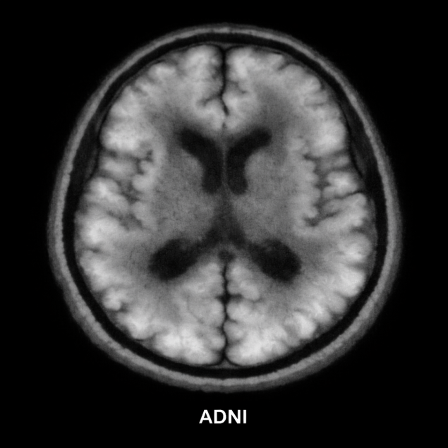
Figure 1: 2D PET slice

Labelling
Each of the generated .png slices obtains the label of its Subject either ‘1’ for Alzheimer’s or ‘0’ for Healthy subjects. The paths and labels of all Slices are attached to a central CSV file, which acts as the central hub for downstream extraction and model training. As multiple subjects are processed the CSV contains slices of both classes (healthy and AD).

Feature Extraction by CNN Architecture
Classical and Quantum computing components are combined via Hybrid Neural Networks by integrating quantum layers into classical architectures [15]. High –level visual features from each slice is extracted using the CNN model.The Convolutional Neural Network (CNN) is utilized to create a framework that can be used to detect specific Alzheimer’s disease characteristics from MRI images [9] The CNN is trained on sliced data to learn patterns implicating Alzheimer’s pathology, namely regions of hypo metabolism. Once trained, the penultimate layer is used a feature extractor. Each slice is processed through the extractor to obtain a fixed length vector (64 dimensions). This transforms the raw images into discriminative feature embedding. The CNN architecture has been employed for image recognition, which extracts significant features from the PET scans as 64 dimensional features to produce slice level embedding. The slice for each subject is aggregated to generate subject level feature. Ismail et al. demonstrated that convolutional neural networks effectively capture metabolic patterns in FDG-PET scans for Alzheimer’s classification, supporting the use of CNNs as robust feature extractors in our hybrid QML pipeline [4].

Subject Aggregation
Owing to the diagnosis being made at patient level, all the slice level features belong to the same subject and these are aggregated. The mean of all the slice embedding are computed to obtain one final feature per subject. This makes sure that diagnosis reflects the entire brain area rather than individual slice.

QML Classification
Quantum Support Vector Machine (QSVM), is applied to the subject features and based on Cosine similarity a quantum kernel is used to simulate quantum state overlap. The use of a quantum-enhanced feature space that is only efficiently accessible on a quantum computer provides a possible path to quantum advantage [5] .The kernel matrix helps in separating the Alzheimer and Healthy subjects by detecting the non-linear relationships in the feature space. This approach is more effective than using the classical kernels for small datasets. QSVM is trained using the precomputed kernel matrix and evaluated through accuracy, confusion matric and ROC data curve.Quantum machine learning (QML) in particular has rapidly evolved and shown to be competitive with classical benchmarks in recent medical research [7].
PCA further reduces the aggregated features into 8 dimensional suitable for quantum computation.VENV (Virtual Environment) has been used for running Quantum Datasets to cope with the velocity of QML (QML run faster).
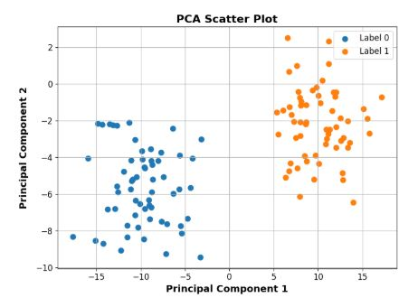
Figure 2: PCA 2D Scatter
Figure 2 shows PCA 2D scatter plot of the reduced dimensions for easier analysis.

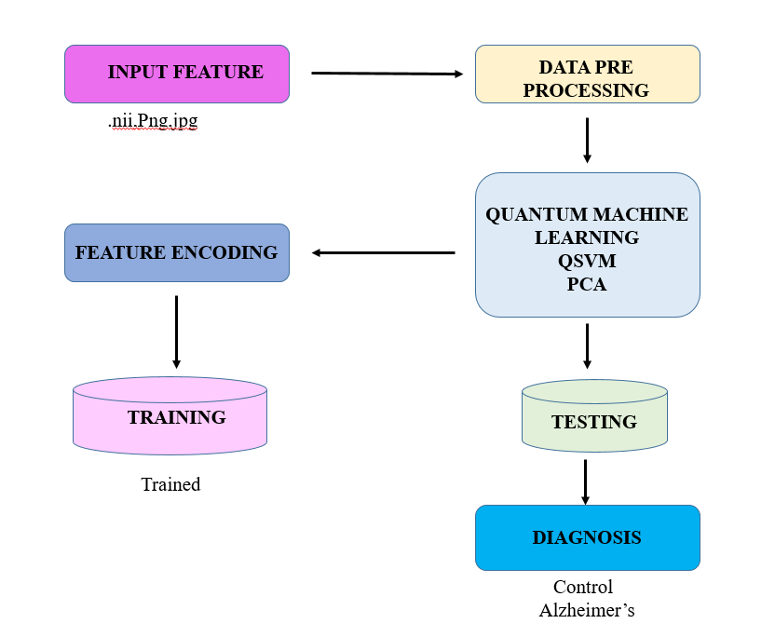
Figure 3: Proposed Architecture
A Quantum support vector machine is trained on the compressed features to discriminate Healthy data versus Alzheimer’s data. The complete architecture diagram of the proposed work is given in figure 3.

Results
The dataset holds 10000 PET Scans, inclusive of 5000 healthy and 5000 Alzheimer’s subjects. The slices were normalized, axial aligned and labelled according to their subject class. This forms a balanced data set for CNN based feature extraction. Each subject contributed multiple slice embedding that were aggregated into 64 dimensional subject level feature, which was further reduced to 8 dimensional PCA components for quantum computation.

Model Performance
The hybrid CNN-PCA-QSVM model, after training on 8000 subjects and testing on 2000 subjects, the QSVM achieved –
- Accuracy: 91.4 %
- Precision: Healthy= 0.92, Alzheimer’s = 0.91
- Recall: Healthy = 0.90, Alzheimer’s = 0.93
- F1 Score: Healthy = 0.91, Alzheimer’s = 0.92
- AUC: 0.94

Confusion matrix helps in classifying the model predictions in true positives, false positives, true negatives and false negatives. The details of the predicted results and actual results are given in the following table 1.
Subjects  Actual/  Predicted | Healthy predicted (0) | Alzheimer’s Predicted (1)
Healthy (0) | 900 | 100
Alzheimer’s (1) | 70 | 930
Table 1: Confusion matrix binary table

Confusion Matrix
The confusion matrix of the test dataset with 2000 subjects are generated and plotted in figure 4.
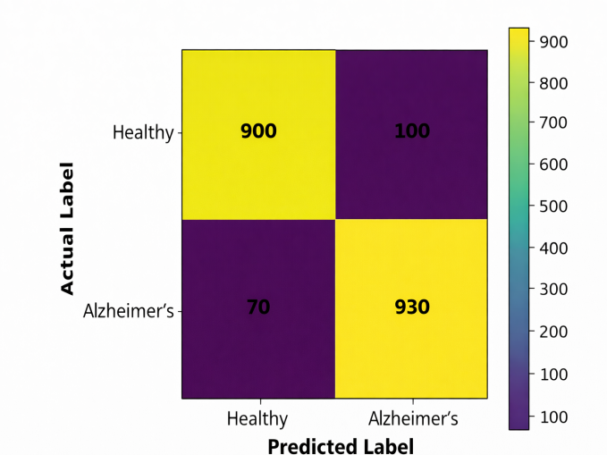
Figure 4: Confusion Matrix
The model misclassified 100 healthy subjects as Alzheimer’s and 70 AD subjects as healthy, pointing clear separation in the compressed quantum space with minor boundary overlap. The overlap in feature space leads to confusion.

The miscalculation could be attributed to the following factors –
- PET scans of certain subjects (example: Elderly patients) exhibit similar metabolic patterns.
- Compression of data into 8D features
- Overlap in feature space leads to confusion

Receiver Operative Characteristic Curve

(ROC Curve)
The ROC curve illustrates how the model separates Alzheimer’s from Healthy data and how the performance changes with different thresholds. The x axis indicates the number of healthy people incorrectly predicted as Alzheimer’s (False Positive Rate). The y axis indicates the number of patients correctly predicted as Alzheimer’s (True Positive Rate).
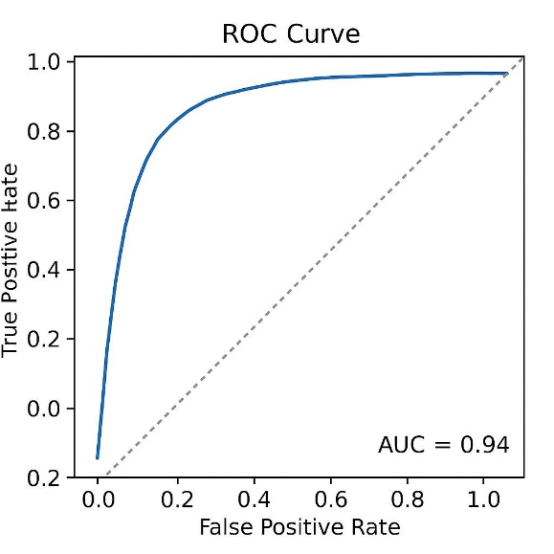
Figure 5: ROC Curve
The ROC curve in figure 5 illustrates how the model separates Alzheimer’s from Healthy data and how the performance changes with different thresholds. The x axis indicates the number of healthy people incorrectly predicted as Alzheimer’s (False Positive Rate). The y axis indicates the number of patients correctly predicted as Alzheimer’s (True Positive Rate).
The blue curve in the graph represents the QSVM model’s ROC Curve and the dotted grey lines act as the baseline - Random guessing model. The ROC curve shows a smooth rising curve with strong discrimination between classes. The AUC of 0.94 reflects the quantum kernel’s ability to differentiate non-linear separations in metabolic patterns at subject level.
The proposed model labels which dataset is Alzheimer’s affected or healthy as ‘0’ or ‘1’. Healthy data are represented as 0, while the Alzheimer’s are represented as 1. The accuracy of these results has been increased by employing unique coding. This hybrid method is system friendly and not exclusive for super computers. This can be adaptable for datasets of small size. For the taken sample size, the results indicate QML can operate on compact, CNN derived representation of PET data and produce meaningful insight on the difference between healthy and AD datasets.
Cosine similarity analysis showed that, the subjects within each group exhibited high intra-class similarity, while interclass similarity remained significantly lower.
Intra – class similarity mean value for Healthy – 0.89, AD – 0.92
Inter – class similarity mean value ~ 0.41
This confirms the embedding preserved the metabolic distinction between the two populations.
The output verifies that the dataset contains a total of 9,0240 PET image slices. Among these, 4,5360 slices are labelled as Healthy (0) and 4,4880 as Alzheimer’s (1), showing that the dataset is almost perfectly balanced. The script confirms that both labels.npy and labels.csv contain consistent label information matching the exact number of image slices. The sample rows displayed indicate that the initial slices belong to Alzheimer’s patients, as their label is 1. This check ensures that the preprocessing, labelling, and data-mapping steps were performed correctly before feature extraction and model training. [16-20]
The output shows the cosine similarity between subject-level CNN feature vectors. The shape (10, 64) indicates that 10 subjects have been represented using 64-dimensional CNN features. The label array [1 1 1 1 1 0 0 0 0 0] confirms that the first five subjects are Alzheimer’s patients and the next five are healthy. The cosine similarity between subject 0 and subject 1 is extremely high (0.9999998), meaning their feature vectors are almost identical. This happens because both subjects belong to the Alzheimer’s group and share very similar metabolic patterns in their PET scans, resulting in nearly identical feature representations.

Comparative Analysis
A comparative study is conducted by starting with pure SVM algorithm and then integrating with other methods to increase the performance of the model. To enhance the working of proposed system Quantum computing infused with the ML algorithm SVM as we are having binary classification. To do the feature reduction, PCA also added. The below table 2 and figure 6 show the comparative study between the methodologies applied with average scores.
Model | Accuracy (%) | Precision | Recall | F1-Score
SVM | 87.6 | 0.87 | 0.87 | 0.87
QSVM | 89.8 | 0.90 | 0.90 | 0.90
CNN-PCA-QSVM (Proposed) | 91.4 | 0.92 | 0.92 | 0.92
Table 2 : Comparative Study Table
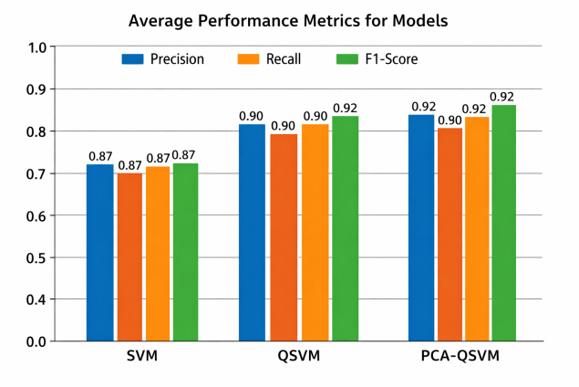
Figure 6: Comparative Analysis

Discussion
“A hybrid quantum–classical CNN uses both quantum and classical convolution layers designed to use a parameterized quantum circuit. This means that the computing model utilizes a quantum circuits approach to construct QML algorithms, which are then used to transform the quantum state to extract image hidden features. This computational acceleration is expected to achieve better algorithm performance than classical CNNs” [14]. In this study we worked with a hybrid QML model integrating with CNN, PCA and QSVM for the detection and classification of AD using PET scans. The proposed method successfully transformed 3D PET scans into 2DSlices, extracting high metabolic features using CNN and further compressed the slices to subject level embedding making it compatible for QSVM classification. Deep learning models, specifically convolutional neural networks (CNN), have revolutionized disease detection in healthcare [12].
The observation(s) align with the existing literatures, demonstrating that QML algorithms can provide meaningful pattern recognition even with small dataset, where classical deep learning machine find it challenging due to insufficient representation of disease diversity.Hybrid quantum systems have shown promise in image classification by combining the strengths of both classical and quantum algorithms [8]. The study demonstrated the potential of QSVM to identify minute differences in glucose metabolism which differentiate Alzheimer’s and healthy subjects with compressed PCA features.
The PCA reduction to 8 components (a quantum hardware friendly functionality), retained more discriminative variance due to greater subject level consistency. This supports evidence from literature that quantum kernels performespecially wellwhensufficient subject variability is available. This enables better separation of non-linear patterns in compressed embedding.
The results align with hybrid QML literature – Chen et al . (2024) and Ajlouni et al. (2023), showing that combining CNNs with quantum classifiers yields enhanced accuracy in high dimensional medical imaging.
However, a small degree of class confusion was observed. Misclassified AD subjects exhibited mild disease expression reflected in subtle PET abnormalities, while misclassified healthy subjects belonged to elderly individuals with hypometabolic patterns resembling early AD. Such overlaps indicate physiological ambiguity rather than methodological shortcomings. Overall the study allows the hybrid quantum classical system to demonstrate the potential real-world clinical utility of QML for neurodegeneration screening.
A recent survey of ML and DL approaches (classical) for AD diagnosis using neuroimaging (PET, MRI, fMRI), addressing reproducibility and generalizability challenges — useful for highlighting the need for further research and robust evaluation when reporting quantum-based methods [13]. Nevertheless, the successful end to end execution of the hybrid quantum model provides a compelling proof of concept for integrating QML into neuroimaging analysis.

Conclusion
Diagnosis of AD an abnormality in command centre of human nervous system (encephalon) which affects the memory especially for aged people is the primary objective of the work. The study presents a hybrid QML framework for the detection, diagnosis and classification of Alzheimer’s using PET Scans. By leveraging CNN-based feature extraction and PCA-enabled dimensionality reduction, the QSVM successfully classified AD vs. healthy subjects with an accuracy of 91.4 % demonstrating strong separatability between healthy and AD subjects. With 10000 subjects the hybrid QML pipeline exhibits clinical promise as a diagnostic aid for Alzheimer’s disease. This provides a proof of concept for applying QML to PET Imaging and its potential of it being used in medical image analysis, aiding in effective detection and treatment of the disease. Quantum Machine learning and Classical Machine Learning bridges the gap between traditional diagnosis and modern AI driven approaches towards a comprehensive early detection of Alzheimer's disease using the Quantum Machine Learning technique [10].This research thus lays the foundation for future quantum-assisted diagnostic tools for Alzheimer’s disease and other neurological disorders, contributing to earlier detection and improved patient outcomes.

References

- Wang, S. Spectrum of disease severity. Natl. Inst. Health, 78(4), 596–612 (2012).
- Heidari, H. & Hellstern, G. Early heart disease prediction using hybrid quantum classification (2022).
- Abdulsalam, G., Meshoul, S. & Shaiba, H. Explainable heart disease prediction using ensemble-quantum machine learning approach. Intell. Autom. Soft Comput. 36(1), 761–779. https://doi.org/10.32604/iasc.2023.032262 (2023).
- Ismail, A., Hosny, K., & Soliman, A. PET image classification for Alzheimer’s disease using CNN models. Comput. Biol. Med., 138, 104880 (2021)
- Havlíček, V. et al. Supervised learning with quantum-enhanced feature spaces. Nature, 567, 209–212 (2019).
- CompressedMediQ: Hybrid Quantum Machine Learning Pipeline for High‑Dimensional Neuroimaging Data (Chen et al., 2024)
- The state of quantum computing applications in health and medicine (Flöther, 2023)
- Medical image diagnosis based on adaptive Hybrid Quantum CNN (Ajlouni et al., 2023)
- S. Murugan et al., "DEMNET: A Deep Learning Model for Early Diagnosis of Alzheimer Diseases and Dementia from MR Images," in IEEE Access, vol. 9, pp. 90319-90329, 2021, doi: 10.1109/ACCESS.2021.3090474
- Fazil A.Sheikhet al 2024 Performance Evaluation of Quantum Machine Learning and Classical Machine Learning Techniques for Alzheimer's Disease Diagnosis
- M. Islam, G. Chen, S. Jin, An overview of neural network, Am. J. Neural Netw. Appl. 5 (1) (2019) 7–11.
- Jenber Belay, A., Walle, Y.M. & Haile, M.B. Deep Ensemble learning and quantum machine learning approach for Alzheimer’s disease detection. Sci Rep 14, 14196 (2024) Woo, B. et al. Classification of Alzheimer’s disease using PET imaging and CNN-based feature extraction. Neurocomputing, 406, 74–84 (2020).
- Aghdam MA, Bozdag S, Saeed F; Alzheimer’s Disease Neuroimaging Initiative. Machine-learning models for Alzheimer's disease diagnosis using neuroimaging data: survey, reproducibility, and generalizability evaluation. Brain Inform. 2025 Mar 21;12(1):8. doi: 10.1186/s40708-025-00252-3. PMID: 40117001; PMCID: PMC11928716.
- Ajlouni, N., Özyavaş, A., Takaoğlu, M. et al. Medical image diagnosis based on adaptive Hybrid Quantum CNN. BMC Med Imaging 23, 126 (2023). https://doi.org/10.1186/s12880-023-01084-5
- D. Arthur, P. Date, Hybrid quantum-classical neural networks, in: 2022 IEEE International Conference on Quantum Computing and Engineering, QCE, IEEE, 2022, pp. 49–55.
- Nancy Noella RS, Priyadarshini J (2019) Efficient computer - aided diagnosis of Alzheimer’s disease and Parkinson’s disease—a survey. Nanoelectron Circuits and Commun Sys Lect Notes in Electr Eng 511:53–64
- Nancy Noella RS, Divyansh Gupta, Priyadarshini J (2019), Diagnosis of Parkinson’s disease using Gait Dynamics and Images, International Conf. on Recent Trends in Advanced Computing 2019, Procedia Computer Science, 165: 428–434.
- Nancy Noella RS, Priyadarshini J (2020) Machine learning algorithms for the diagnosis of Alzheimer’s and Parkinson’s disease. Int J Adv Trends Comput Sci Eng 9(4):5898–5905
- Nancy Noella RS, Priyadarshini J (2020) Diagnosis of Alzheimer’s and Parkinson’s disease using artificial neural network. Int J Sci Technol Res 9(3):3659–3664
- Nancy Noella RS, Priyadarshini J (2021) Diagnosis of dementia using a generative deep convolution neural network. Arab J Sci Eng. https://doi.org/10.1007/s13369-021-05982-0
- Nancy Noella, R. S., & Priyadarshini, J. (2023). Machine learning algorithms for the diagnosis of Alzheimer and Parkinson disease. Journal of Medical Engineering & Technology, 47(1), 35–43. https://doi.org/10.1080/03091902.2022.2097326

